Committee Membership for
Daniel Michael Smith NRDS# 846504145
Title |  | Year
NVAR Federal Credit Union |  | 1989
Above is the committee and year Mr. Smith has served.
Mr. Smith has served as a Committee Member of the NVAR Federal Credit Union Committee in 1989.
Verna F. Vargas
Member Engagement Supervisor

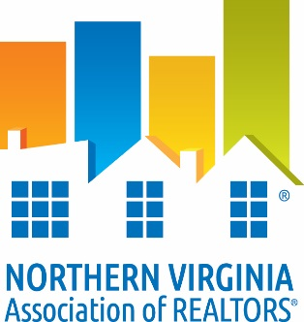

DATE: ___September 8, 2016_________

TO: Whom It May Concern
RE: Verification of Membership and National and/or State Dues Waiver
The following information is to verify NVAR membership status.

I. Candidate Information:

___ Daniel Michael Smith ______________ ____ 0225001457_______ _
Name VA License #

___ RE/MAX 100 ___________ ____ 846504145 ____ _
Firm NAR ID
II. Membership Verification:
To Be Completed by Current Association ONLY

_X_ Member is verified as a member in good standing of NVAR since 1976_________
(Association Name)

_X_ Member does not have current/pending disciplinary action or unsatisfied fines with
current association.
_X_ Member has satisfied NAR Quadrennial Ethics requirement through one of the following:
__ Orientation ____________ _X Continuing Education __7/31/15______
(date completed) (date completed)

_X_ VAR dues paid for year of _2016____________

_X_ NAR dues paid for year of _2016____________

_X_ SentriLock Fee paid through _2016____________

_Verna F. Vargas _September 8, 2016 _
Member Engagement Supervisor Date

