Committee Membership for Elizabeth M. Barthle:
NRDS#846500260
Title | Year | Board
Standard Forms Committee Member | 2006 | Local
N. Virginia/RPAC Committee Member | 2000 | Local
PC Users Group Committee Member | 1990 | Local
Real Estate Finance Committee Member | 1988 | Local
Residential Specialty Committee Member | 1988 | Local
Training Specialty Committee Member | 1988 | Local
Realtor/Builder Committee Member | 1987 | Local
Above is a list of all the committees and years Ms. Barthle has served.
Ms. Barthle has served as a Committee Member for many years on different committees.
Verna F. Vargas
Member Engagement Supervisor

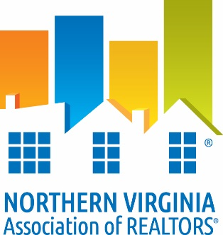

DATE:___April 1, 2016_________

TO: Whom It May Concern
RE: Verification of Membership and National and/or State Dues Waiver
The following information is to verify NVAR membership status.

I. Candidate Information:

___Elizabeth M. Barthle____________ ____0225002107_______ _
Name VA License #

___Long & Foster Real Estate_ __ ____846500260____ _
Firm NAR ID
II. Membership Verification:
To Be Completed by Current Association ONLY

_X_ Member is verified as a member in good standing of NVAR since 1976_________
(Association Name)

_X_ Member does not have current/pending disciplinary action or unsatisfied fines with
current association.
_X_ Member has satisfied NAR Quadrennial Ethics requirement through one of the following:
__ Orientation ____________ _X Continuing Education __9/30/15______
(date completed) (date completed)

_X_ VAR dues paid for year of _2016____________

_X_ NAR dues paid for year of _2016____________

_X_ SentriLock Fee paid through _2016____________

_Verna F. Vargas _April 1, 2016 _
Member Engagement Supervisor Date

