Committee Membership for Cherie Pagett:
NRDS#846503406
Title | Year | Board
N. Virginia/RPAC Trustees Committee Member | 2000 | Local
Property Management & Leasing Committee Member | 2000 | Local
VAR DIRECTOR | 1990 | State
Property Management & Leasing Committee Member | 1989 | Local
Mrs. Pagett has serviced as a Committee Chair for many years on different committees.
She has also served as a Director on the State board.
Above is a list of all the committees and years Mrs. Paggett has served.
Verna F. Vargas
Member Engagement Supervisor

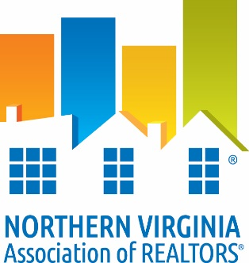

DATE: ___April 1, 2016_________

TO: Whom It May Concern
RE: Verification of Membership and National and/or State Dues Waiver
The following information is to verify NVAR membership status.

I. Candidate Information:

___Cherie A. Pagett ____________ ____0225037781_______ _
Name VA License #

___Edward E. Pagett Real Estate, Inc_ ____846503406____ _
Firm NAR ID
II. Membership Verification:
To Be Completed by Current Association ONLY

_X_ Member is verified as a member in good standing of NVAR since 1976_________
(Association Name)

_X_ Member does not have current/pending disciplinary action or unsatisfied fines with
current association.
_X_ Member has satisfied NAR Quadrennial Ethics requirement through one of the following:
__ Orientation ____________ _X Continuing Education __2/28/15______
(date completed) (date completed)

_X_ VAR dues paid for year of _2016____________

_X_ NAR dues paid for year of _2016____________

_X_ SentriLock Fee paid through _2016____________

_Verna F. Vargas _April 1, 2016 _
Member Engagement Supervisor Date

