Committee Membership for Miriam Nun
NRDS# 846503308

Title | Position | Board Year
Arbitration | Member | 1993
Arbitration | Member | 1988
Above is a list of the committee and year Ms. Nun has served.
Verna F. Vargas
Member Engagement Supervisor

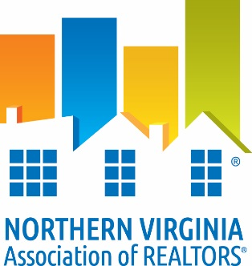

DATE: ___August 23, 2016_________

TO: Whom It May Concern
RE: Verification of Membership and National and/or State Dues Waiver
The following information is to verify NVAR membership status.

I. Candidate Information:

_Miriam J. Nun DBA: Mimi Nun_____ ____0225117464_______ _
Name VA License #

___Long & Foster Real Estate Inc. __ ____846503308____ _
Firm NAR ID
II. Membership Verification:
To Be Completed by Current Association ONLY

_X_ Member is verified as a member in good standing of NVAR since 1975_________
(Association Name)

_X_ Member does not have current/pending disciplinary action or unsatisfied fines with
current association.
_X_ Member has satisfied NAR Quadrennial Ethics requirement through one of the following:
__ Orientation ____________ _X Continuing Education __2/28/15______
(date completed) (date completed)

_X_ VAR dues paid for year of _2016____________

_X_ NAR dues paid for year of _2016____________

_X_ SentriLock Fee paid through _2016____________

_Verna F. Vargas _August 23, 2016 _
Member Engagement Supervisor Date

