Georgia REALTORS® Unveil New Logo in 2013

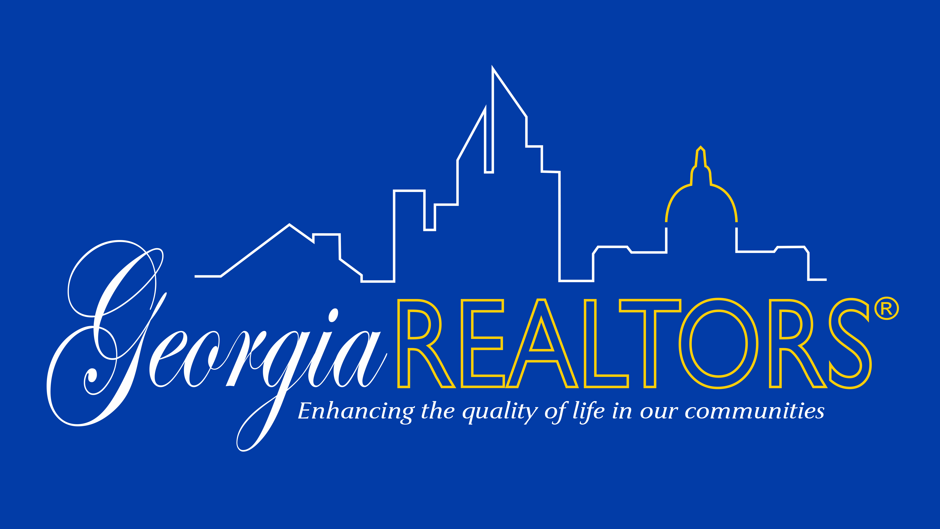

As part of GAR's ongoing efforts to update our mission, purpose, and image, we unveiled a new logo this past May, which is the first revision to our most prominent visual in eight years. In 2012, a new strategic plan, mission statement and core purpose was crafted by GAR’s Strategic Planning Committee along with a Presidential Advisory Group (PAG) that researched branding options for the Association. It was determined that a newer, more modern logo was a necessary component in the process of updating our image.

The logo features the Association’s shortened name – Georgia REALTORS® - and incorporates three elements that encompass our membership in the “skyline” area of the image. The first element in the skyline is a house, which represents residential real estate. The second element featured is a group of high-rise buildings, which represents commercial real estate. The third element in the logo is the gold dome of the Georgia Capitol building, which represents the advocacy efforts of all Georgia REALTORS®. Finally, our vision statement – enhancing the quality of life in our communities – is incorporated along the bottom of the logo.

