NFIP Toolkit for REALTORS®
Louisiana REALTORS® (LR) developed a toolkit for REALTORS® to provide a portal for REALTOR® members and other consumers to receive up-to-date and important information about changes to the National Flood Insurance Policy (NFIP). The NFIP Toolkit is hosted on the Louisiana REALTOR® Association homepage, www.LAREALTORS.org.
The toolkit consists of a tabbed menu bar which allows the user to interact with four information categories: Tools for REALTORS®, NFIP Background Information, News and Resources and Videos.

Our toolkit is an evolving, user friendly “one-stop shop” which provides REALTORS®, their clients and other consumers with useful information about the NFIP.
Tools for REALTORS®: This is the core of the toolkit andprovides forms, webinars, PowerPoints, learning tools and other resources.
NFIP Background Information: Features information to give REALTORS® a basic understanding of the issues including legislative history of the Biggert Waters Act, claims information and other resources .
News and Resources: This section chronologically highlights news releases, legislative updates and media coverage of the NFIP. It offers a history of events regarding NFIP changes and provides REALTORS® a valuable research resource.
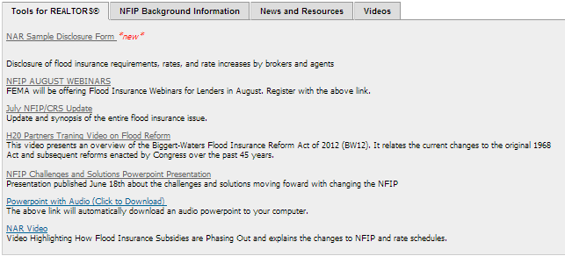
Videos: In this tab, users will find LR, National Association of REALTORS® and news media video publications pretaining to the NFIP.

