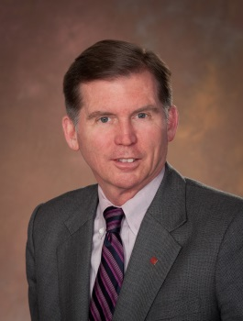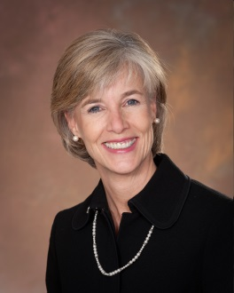
Bill Milliken, President Carol Griffith, President - Elect
2013 President’s Report
Michigan Association of REALTORS®
The Michigan Association of REALTORS® continues to play a vital role in Michigan’s systematic overhaul and “reinvention”. The Association has strongly supported Governor Snyder and our state legislature as they have taken some tough, but necessary steps to turn Michigan’s economy around. By passing needed government reforms, reducing regulation, and eliminating burdensome taxation, Michigan is better-positioned to attract businesses and investment, spur the housing market, and create jobs in the state.
As Michigan’s economy becomes more vibrant and diverse, investment in the state from around the globe has been a bellwether for just how fertile the business climate has become in Michigan. This past summer “Realtor.com” published some very compelling international statistics along these lines. Detroit ranked as the #1 searched city by international consumers on the website for two consecutive months this summer. Topping the likes of Los Angeles and Miami, this ranking indicates that the rest of the world sees opportunity in one of Michigan’s greatest, albeit distressed, cities. Investors and Consumers both see opportunity.
As Michigan REALTORS®, we are doing the same – rethinking the established local business model and embracing a new, international real estate market as it relates to our state.
The Michigan Association of REALTORS is also taking a “boots on the ground” approach in bolstering efforts to restore Detroit as a great American city. Partnering with the philanthropic Skillman Foundation and other community-based organizations, the MAR and its local real estate leaders have committed to do their part to help foster a stronger, more dynamic Detroit.
RPAC continues to thrive in Michigan. This year our Association sponsored the composition and production of our own RPAC Anthem, “Yours for a Song,” as a new and innovative fundraising tool. We partnered with the NAR in rolling out a promotional video for the song to help galvanize fundraising efforts statewide. It is our intent to promote the song and its message going forward to help spur involvement at the local and state level. The strength of RPAC in Michigan is the key to our continued advocacy and involvement in Michigan’s political future.

