YOUR EXPERT
(Name), REALTOR®
(Address
Phone Number
E-mail
Social Media)

(Insert photo here)

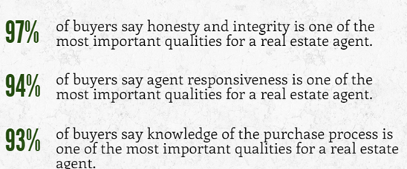
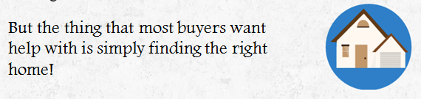

´UserField1ª ´LASTNAMEª ´MailingAddressStreetª
´MailingAddressCityª, ´MailingAddressStateª ´MailingAddressPostalCodeª

PRSRT STD
U.S. POSTAGE PAID NEW BRUNSWICK, NJ
PERMIT NO. 30039

If your home is currently listed with a Real Estate Broker, please disregard this offer.

^{Produced by the National} ^{Association of REALTORS®}

YOUR EXPERT
(Name), REALTOR®
(Address
Phone Number
E-mail
Social Media)

(Insert photo here)
PRSRT STD
U.S. POSTAGE PAID City, State
PERMIT NO. #####

´UserField1ª ´LASTNAMEª ´MailingAddressStreetª
´MailingAddressCityª, ´MailingAddressStateª ´MailingAddressPostalCodeª

PRSRT STD
U.S. POSTAGE PAID City, State
PERMIT NO. #####

If your home is currently listed with a Real Estate Broker, please disregard this offer.

^{Produced by the National} ^{Association of REALTORS®}
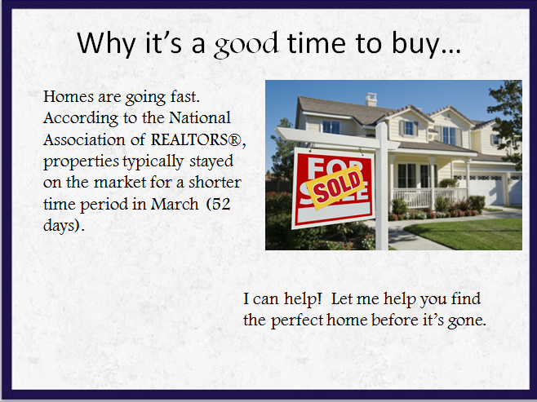
(Insert photo here)
^{Produced by the National} ^{Association of REALTORS®}

(Insert photo here)
^{Produced by the National} ^{Association of REALTORS®}

